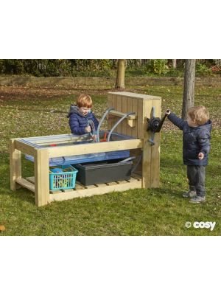 |  |  | 2 |  | 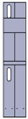 | 1 |  | 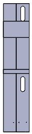 | 1 |  | 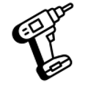
 |  |  | 1 |  |  | 1 |  |  | 1 |  | 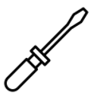
 |  | 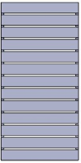 | 1 |  | 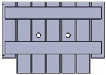 | 1 |  |  | 1
 |  | 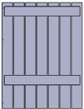 | 1 |  | 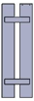 | 1 |  | 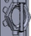 | 2
 |  | 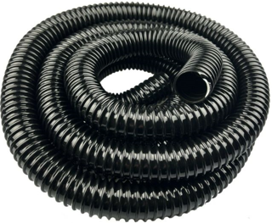 | 4 |  | 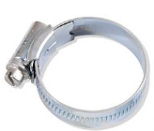 | 4 |  | 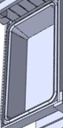 | 1
 |  |  | 1 |  | 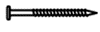 50mm | 22 |  | 40mm | 8
 |  | 30 mm | 48

34934 – Double Pump Station
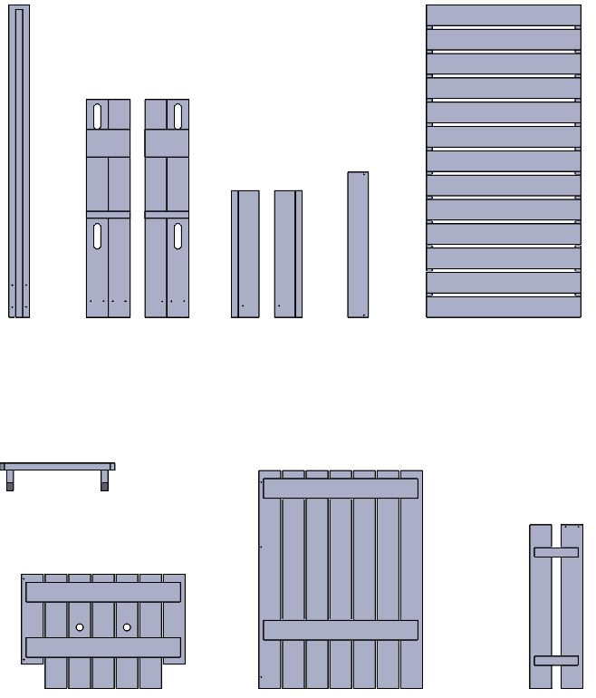  B  K  J  I  H  G  F  E  D  C  Ax2 | 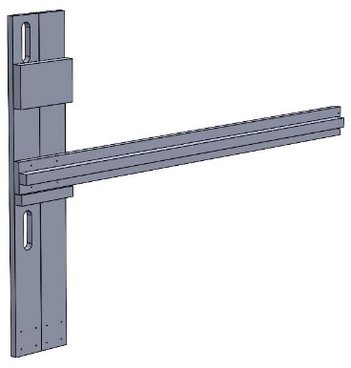  S  S  S  S  B  A | 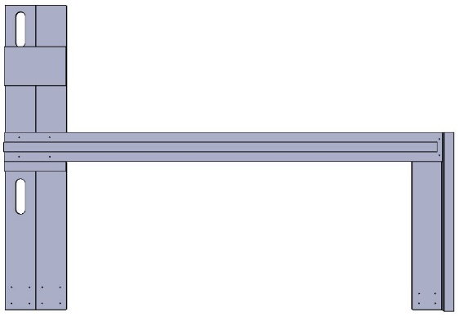  D
 | 1 | 2
 | 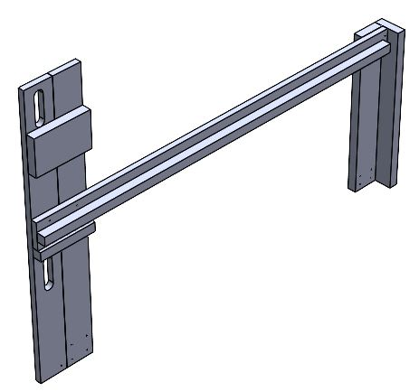  R  R | 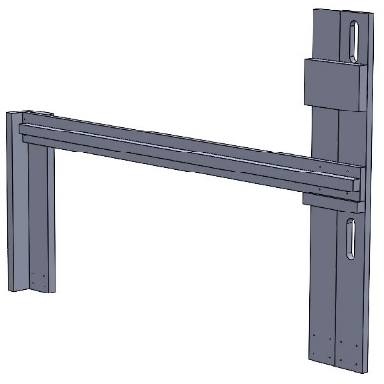  4 x S  2 x R  E  C  A
 | 3 | 4

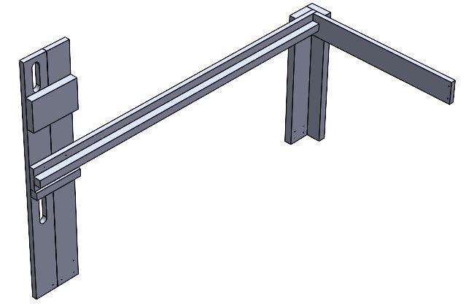  R  R  F | 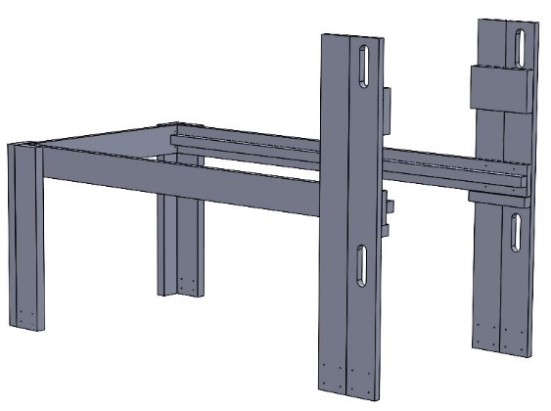  R  R | 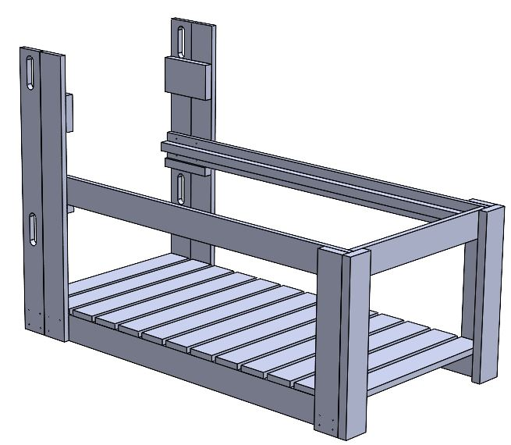  8 x S  4 x Q  G | 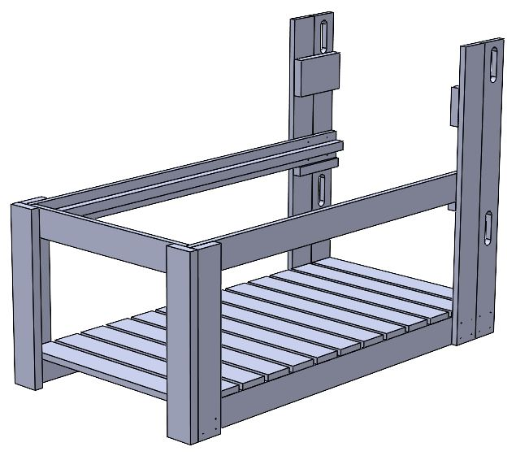  4 x Q  8 x S
5 | 6 | 7 | 8
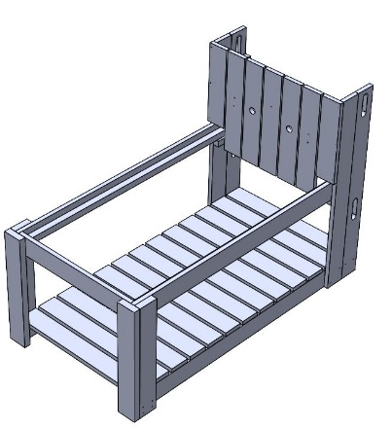  S  S  S  S  S  S  H | 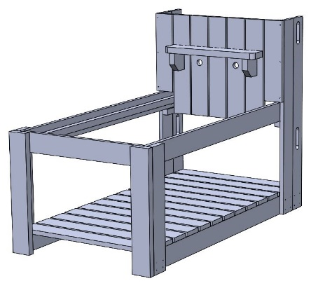  H | 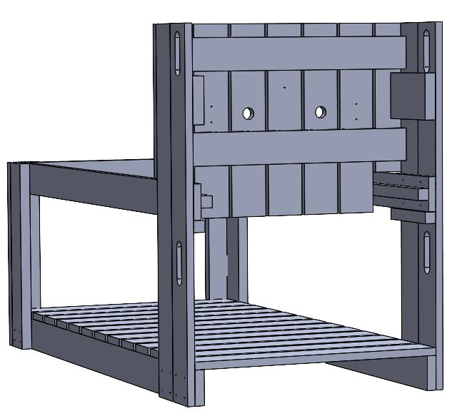  Q  Q  Q  Q  Q | 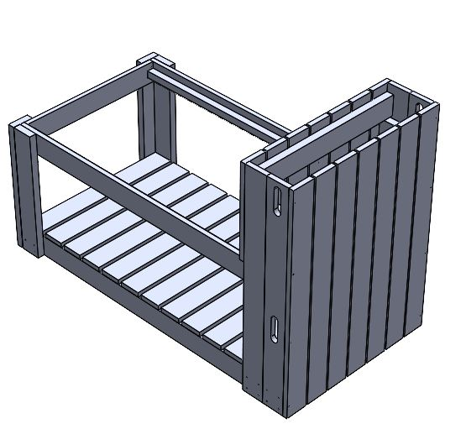  S  S  S  S  S  S  S  S  J
9 | 10 | 11 | 12

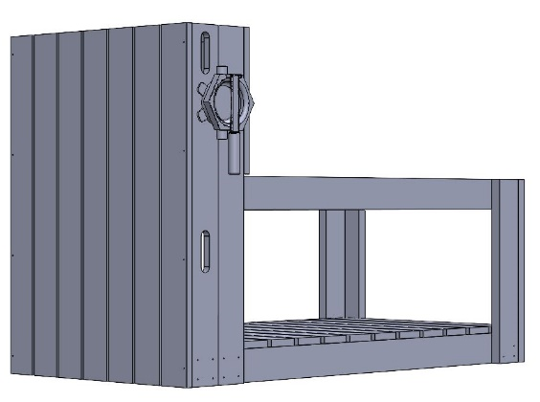  4 x Q  L | N M  N M  M  M | 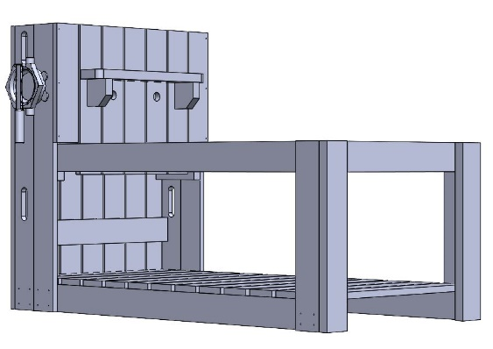 |   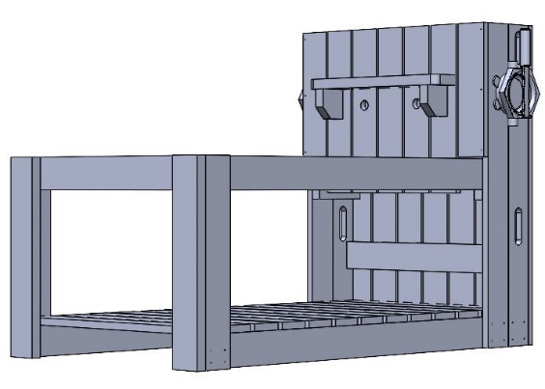  13 – 15
13 | 14 | 15 | 16
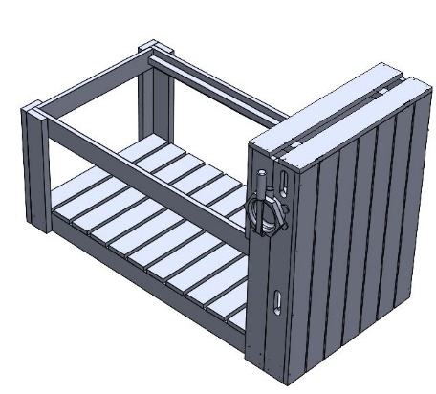  2 x S  2 x S  2 x S  2 x S  K | 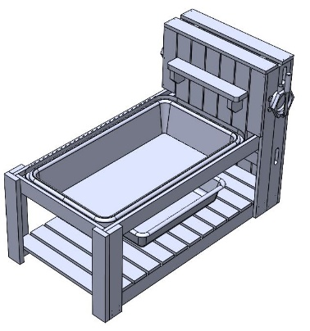  P  O | 
17 | 18 | 19

