28618 - MATHS STATION
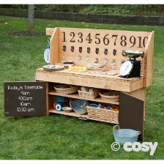
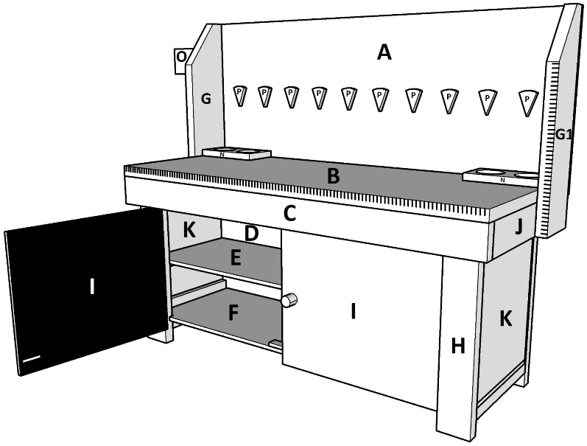

28618 - MATHS STATION
 | 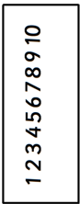 | 1 |  | 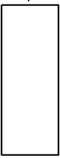 | 1 |  |  | 2 |  |  | 1 |  | 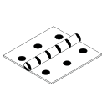
 |  | 1 |  | 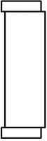 | 1 | G. | 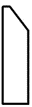 | 1 | G1. | 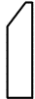 | 1 |  | 
H. |  | 4 | I. |  | 2 | J. |  | 2 | K. | 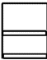 | 2
N. |  | 2 | O. |  | 1 | P. |  | 10 | Q. | 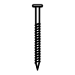3,0x12mm
R. | 3,5x25mm |  | S. | 3,5x12mm |  | T. | 4,0x50mm |  | U. | 4,0x55mm
V. | 4,0x70mm |  |  |  |  |  | 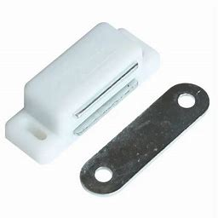

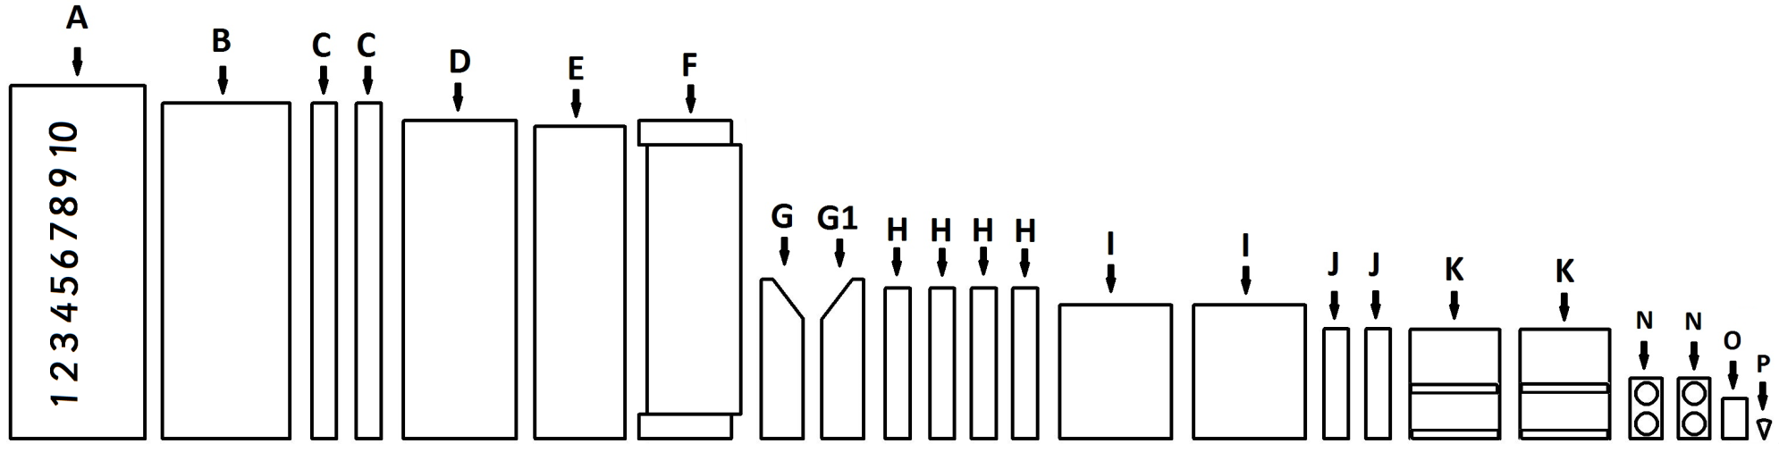
1.

28618 - MATHS STATION
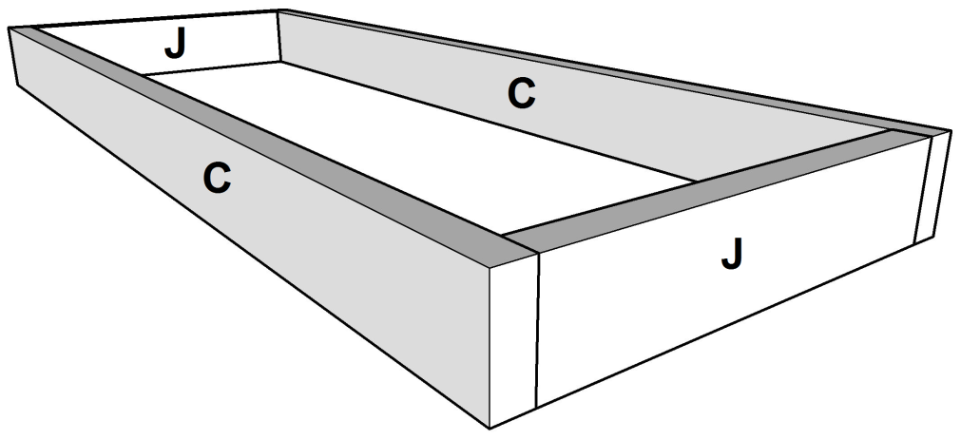  T  T  T  T | 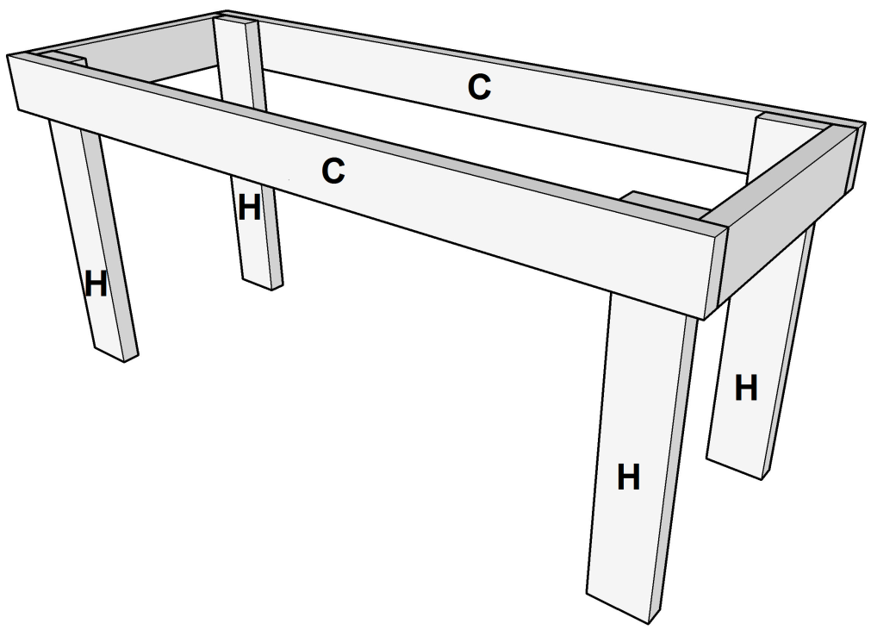  T  T  T  T
2. | 3.

28618 - MATHS STATION
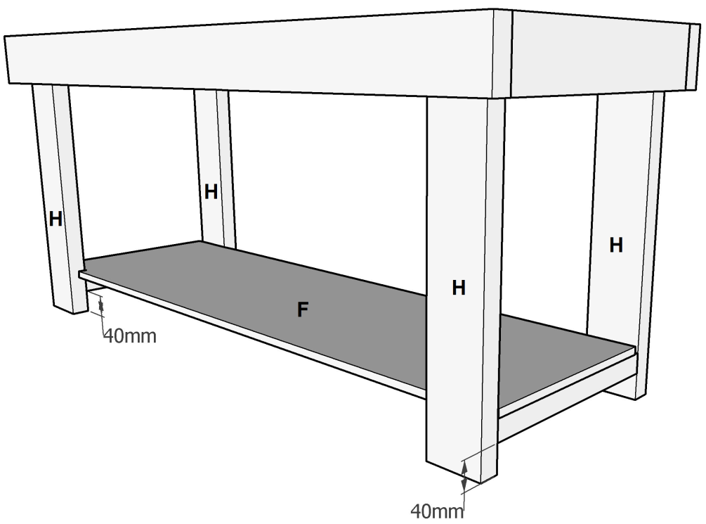  V  V  V  V | 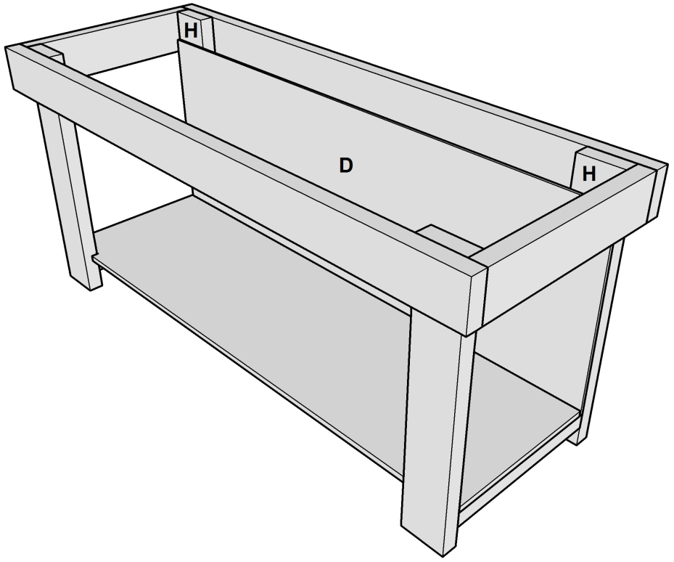  R  R  R  R
4. | 5.

28618 - MATHS STATION
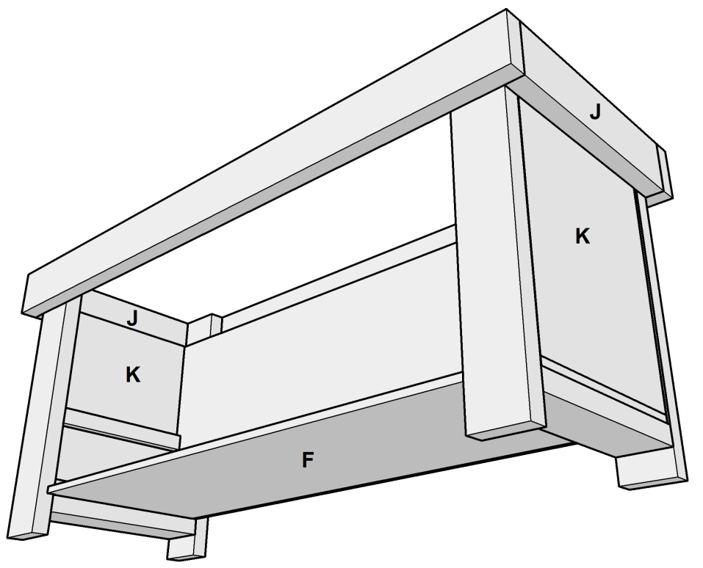  U  U  U  U  R  R  R  R | 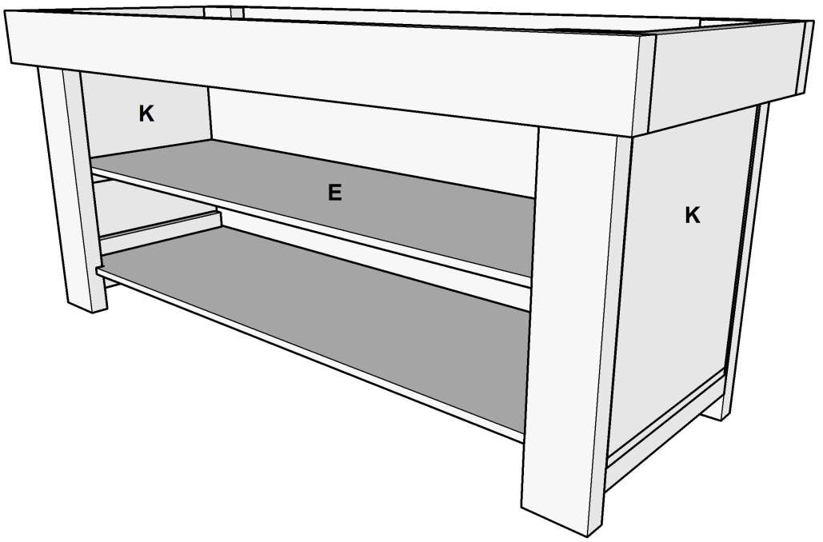  R  R
6. | 7.

28618 - MATHS STATION
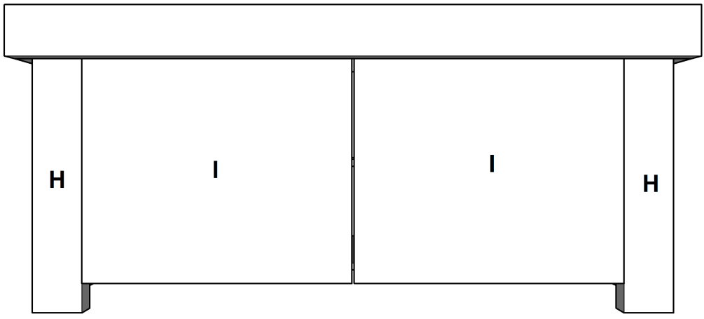  V  V  R  R | 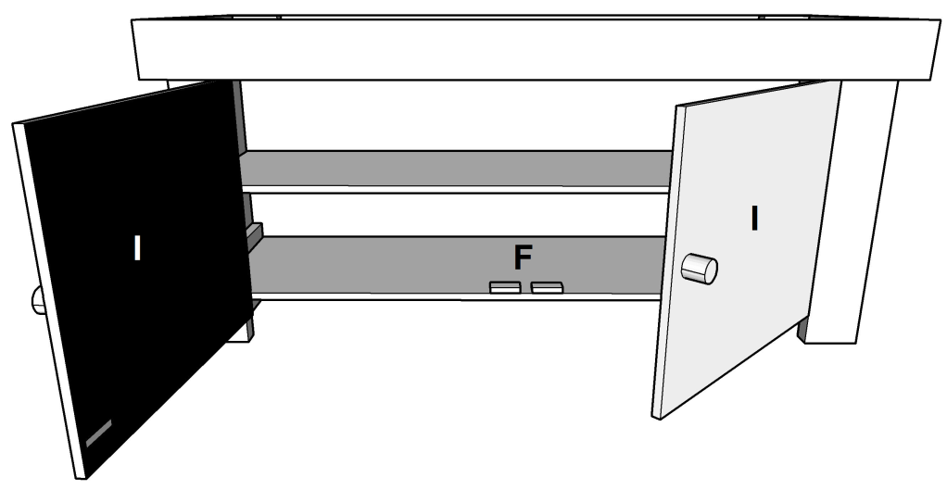  Q  Q
8. | 9.

28618 - MATHS STATION
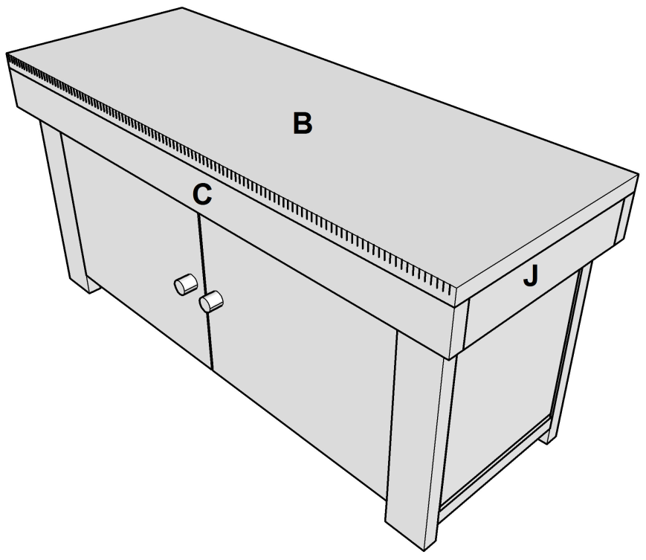  T  T | 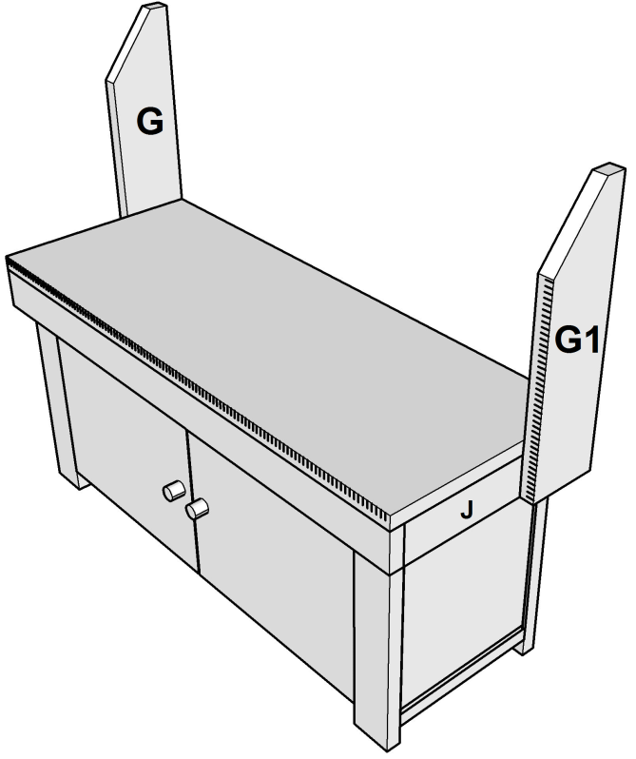  T  T
10. | 11.

28618 - MATHS STATION
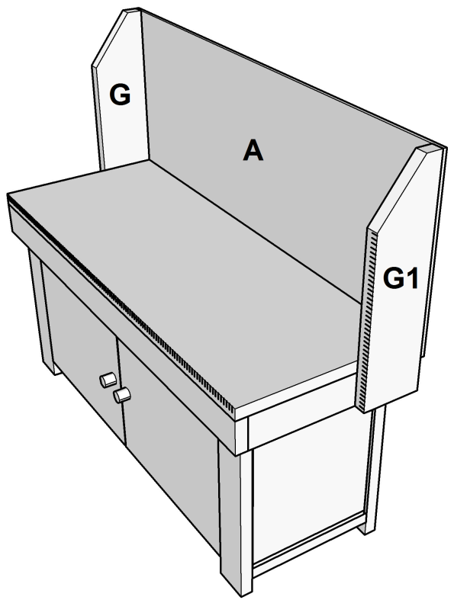  R  R | 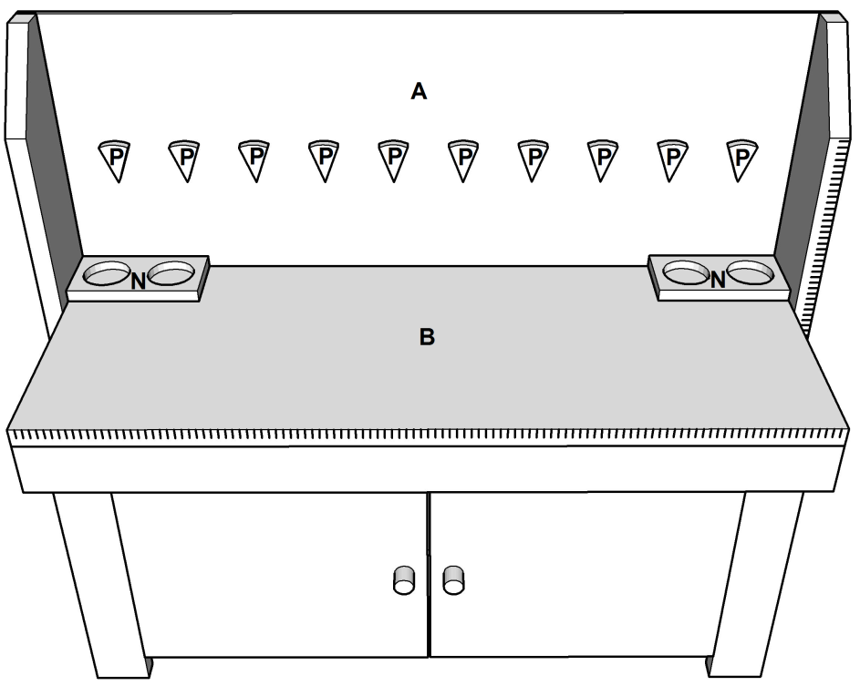  S  S  S  S  S  S  S  S  S  S  R  R
12. | 13.

28618 - MATHS STATION
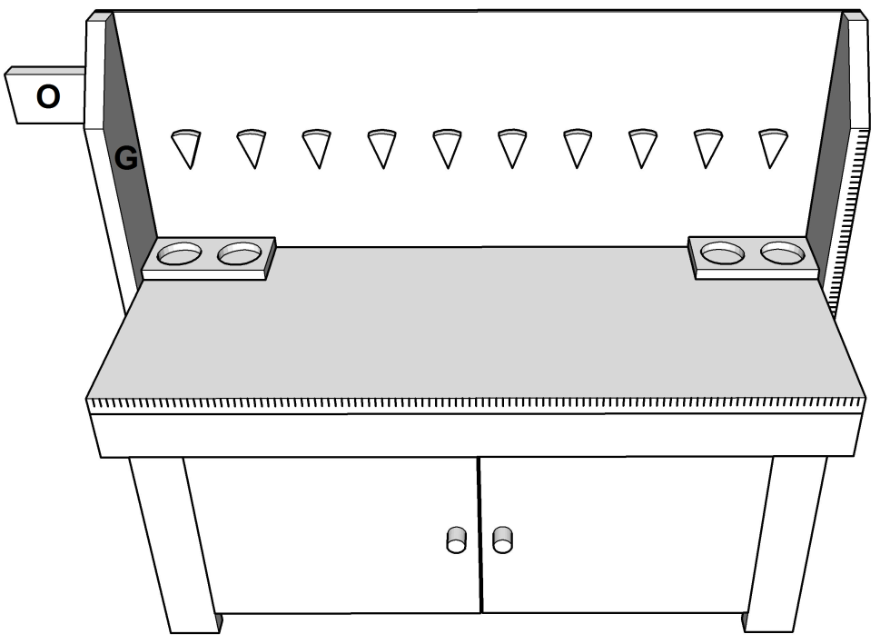  V | 
14. | 15.

